

RAFFLES INSTITUTION
PRELIMINARY EXAMINATION 2010

Higher 1

CHEMISTRY 8872/01

Paper 1 Multiple Choice 27 September 2010

50 minutes

Additional Materials: OMR Answer Sheet
Data Booklet

READ THESE INSTRUCTIONS FIRST

DO NOT open this booklet until you are told to do so.

Write in soft pencil.
Do not use staples, paper clips, highlighters, glue or correction fluid.
Write your name, class and index number in the spaces provided on the Answer Sheet.

There are thirty questions on this paper. Answer all questions. For each question there are four possible answers A, B, C and D.
Choose the one you consider to be correct and record your choice with a soft pencil on the separate Answer Sheet.

Read the instructions on the Answer Sheet very carefully.

Each correct answer will score one mark. A mark will not be deducted for a wrong answer. Any rough working should be done in this booklet.

This document consists of 11 printed pages.
Section A

For each question there are four answers, A, B, C and D. Choose the one you consider to be correct.

1. Which of the following has the greatest mass?

A | 1.2 x 10²⁴ atoms of iron
B | 3.0 x 10²³ copper(II) ions
C | 3.0 moles of nitrogen molecules
D | 6.0 x 10²³ atoms of helium gas

2. 10.0 cm³ of 0.200 mol dm‾³ of K₂XO₄ reacts with 40.0 cm³ of 0.100 mol dm‾³ of iron(II) sulfate solution. If Fe²⁺ is oxidised to Fe³⁺ by K₂XO₄, what is the final oxidation state of X?

A | +2 | B | +3 | C | +4 | D | +5

3. In which sequence are Br–, Rb⁺ and Sr²⁺ ions ranked in order of increasing radii?

 | smallest | → | largest
A | Sr²⁺ | Br– | Rb⁺
B | Br– | Rb⁺ | Sr²⁺
C | Rb⁺ | Sr²⁺ | Br–
D | Sr²⁺ | Rb⁺ | Br–

4. Which of the following corresponds to the third ionisation energy of chromium?

A | Cr²⁺(g) → Cr ³⁺(g) + e–
B | Cr ³⁺(g) + e– → Cr ²⁺(g)
C | Cr(g) → Cr ³⁺(g) + 3e–
D | Cr ²⁺(s) → Cr ³⁺(g) + e–

5. Which of the following species has a square planar shape?

A | CH₄ | B | BrF₄– | C | AlCl₃ | D | PBr₅

6. Which of the following shows compounds ranked in order of increasing boiling points?

A | NaCl, CH₃OH, CH₃CH₃
B | CH₃OH, CH₃CH₃, NaCl
C | CH₃CH₃, CH₃OH, NaCl
D | CH₃OH, NaCl, CH₃CH₃

7. The value of the enthalpy change for the process represented by the equation,

½O₂(g) + 2e– → O^{2–}(g)

is equal to

A | sum of the first and second electron affinity of oxygen
B | sum of the enthalpy change of atomisation and the first and second electron affinity of oxygen
C | sum of the first ionisation energy and the first electron affinity of oxygen
D | sum of the bond energy of (O=O) and the first and second electron affinity of oxygen

8. Tetrachloroethene is a colourless liquid widely used for the cleaning of fabrics. The equation below shows the production of tetrachlorethene from ethene, hydrogen chloride and oxygen.

C₂H₄(g) + 4HCl(g) + 2O₂(g) → C₂Cl₄(l) + 4H₂O(l)

Using the following information, calculate the enthalpy change of reaction for the above reaction.

Compound | ΔH_{f} / kJ mol^{–1}
C₂H₄ | +52.3
HCl | –92.3
C₂Cl₄ | –52.2
H₂O | –285.8

A | +298.0 kJ mol^{–1}
B | –298.0 kJ mol^{–1}
C | +878.5 kJ mol^{–1}
D | –878.5 kJ mol^{–1}

9. A theoretical reaction involves A → 2B.

Which statement is always correct?

A | The overall order of reaction is one.
B | Adding a suitable catalyst increases the rate constant of the reaction.
C | Removing B as it is formed helps to increase the rate of reaction.
D | Increasing the concentration of A increases the rate of the reaction.

10. The graph represents the decomposition of a sample of hydrogen peroxide, H₂O₂ in the presence of manganese(IV) oxide.

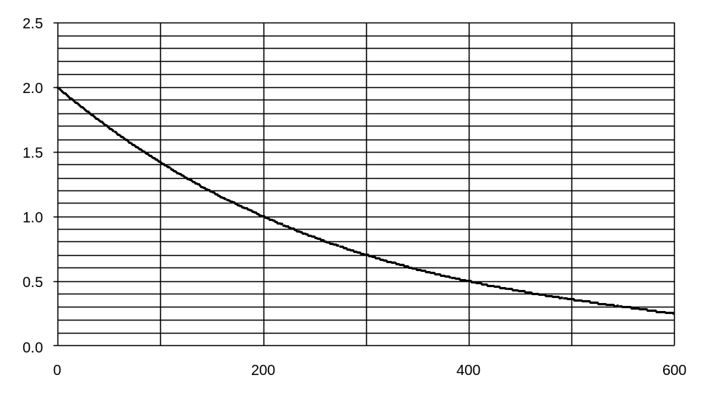
Time/s
[H₂O₂]/mol dm^{–3}

What conclusion can be drawn from the graph?

A | The reaction is zero order with respect to H₂O₂.
B | The rate of decomposition of H₂O₂ is constant.
C | The half–life of H₂O₂ in the sample is 100 s.
D | The rate equation for the decomposition of H₂O₂ is rate = k[H₂O₂].

- The numerical value of the equilibrium constant for the reaction

H₂(g) + I₂(g) 2HI(g)

is 60 at 450 ºC. The number of moles of HI in equilibrium with 2.0 moles of hydrogen and 0.3 moles of iodine at 450 ºC is

A | 0.01 | B | 0.1 | C | 6 | D | 36

12. Phosphorus trichloride and chlorine react according to the following equation:

PCl₃(g) + Cl₂(g) PCl₅(g)

A mixture of PCl₃ and Cl₂ was placed in a syringe and brought to equilibrium. At time t, the plunger of the syringe was suddenly withdrawn such that the resulting volume was twice the initial volume.

Which graph correctly shows the variation of concentration of PCl₅ with time?

A [PCl₅] B [PCl₅]

time
time
t
t

C [PCl₅] D [PCl₅]

time
time
t
t

13. H₃PO₄ is a triprotic acid which has three acid dissociation constants. The table below shows the first, second and third acid dissociation constants, K_{a}, respectively.

Dissociation | Equilibrium in aqueous solution | K_{a}/mol dm^{–3}
First | H₃PO₄(aq) + H₂O(l) H₃O⁺(aq) + H₂PO₄–(aq) | 7.5 x 10^{–3}
Second | H₂PO₄–(aq) + H₂O(l) H₃O⁺(aq) + HPO₄^{2–}(aq) | 6.2 x 10^{–8}
Third | HPO₄^{2–}(aq) + H₂O(l) H₃O⁺(aq) + PO₄^{3–}(aq) | 2.2 x 10^{–13}

Which of the following ranks the conjugate bases in order of increasing basicity?

 | lowest | → | highest
A | PO₄^{3–} | HPO₄^{2–} | H₂PO₄–
B | H₂PO₄– | HPO₄^{2–} | PO₄^{3–}
C | HPO₄^{2–} | PO₄^{3–} | H₂PO₄–
D | HPO₄^{2–} | H₂PO₄– | PO₄^{3–}

14. Which pair of 1 mol dm^{–3} aqueous solutions, when added together, will give a buffer solution of pH > 7?

A | 25 cm³ of hydrochloric acid and 50 cm³ of aqueous ammonia
B | 50 cm³ of hydrochloric acid and 25 cm³ of aqueous ammonia
C | 25 cm³ of ethanoic acid and 50 cm³ of sodium hydroxide
D | 50 cm³ of ethanoic acid and 25 cm³ of sodium hydroxide

15. Which of the following is an incorrect trend of the elements of the Period 3 of the Periodic Table?

A | The radii of the atoms decrease.
B | The oxides of the elements change from basic to acidic.
C | The melting points of the elements decrease steadily.
D | The compounds of the elements change from ionic to covalent.

16. Elements can form oxides with giant structures. The oxide formed can conduct electricity in the molten state.

Which of the following contains two such elements?

A | magnesium, phosphorus
B | sodium, aluminium
C | silicon, phosphorus
D | aluminium, silicon

17. The graph shows how a property of the elements Na to Cl varies with proton number.

proton number
11 12 13 14 15 16 17

What is the property?

A | Electronegativity
B | First ionisation energy
C | Ionic radius
D | Melting point

18. Which class of compounds will the hydrogen atoms to carbon atoms ratio be the highest in its general formula?

A | alcohols
B | aldehydes
C | arenes
D | halogenoalkanes

19. What is the total number of different esters with molecular formula of C₄H₈O₂?

A | 2 | B | 3 | C | 4 | D | 6

20. What is the total number of geometric isomers that can be formed from the product of the reaction of the following compound with excess concentrated sulfuric acid at 170 ºC?
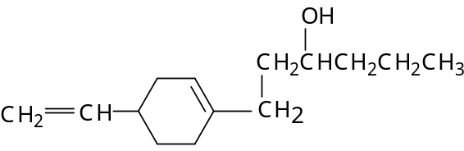

A | 2 | B | 4 | C | 8 | D | 16

- Which hydrocarbon, on treatment with hot acidified potassium manganate(VII), would give propanoic acid only?

A | 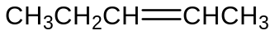
B | 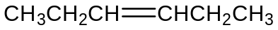
C | 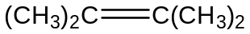
D | 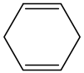

22. On dehydration followed by reaction with bromine, compound X produced a mixture of two dibromo compounds that are structural isomers.

What could compound X be?

A | (CH₃)₃COH
B | (CH₃)₂CHCH₂OH
C | CH₃CH₂CH(OH)CH₃
D | CH₃CH₂CH₂CH₂OH

23. Phenylethanoic acid, C₆H₅CH₂COOH can be synthesised from (bromomethyl)benzene, C₆H₅CH₂Br in the laboratory in two steps.

What are reagents and conditions that can be used for this synthesis?

 | Step 1 | Step 2
A | NaOH(aq), heat | Acidified K₂Cr₂O₇, heat
B | Ethanolic NaOH, heat | Acidified KMnO₄, heat
C | Ethanolic NaCN, heat | HCl(aq), heat
D | Cold HCN, trace amount of NaCN | H₂SO₄(aq), heat

24. | Upon heating, compound X gives yellow precipitate with alkaline aqueous iodine. 2 moles of compound X also give effervescence of 1 mole of hydrogen gas upon reaction with sodium metal. It does not change the colour of hot, acidified sodium dichromate(VI) from orange to green.  What could X be?
 | A | 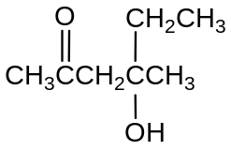
 | B | 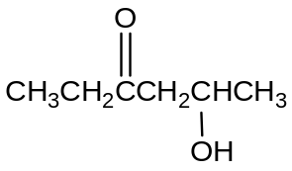
 | C | 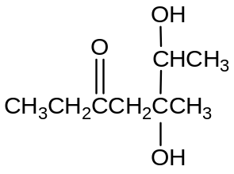
 | D | 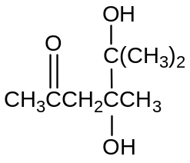

25. Prednisone is a useful drug in the treatment of inflammatory disorders, allergies and malignancies such as leukemia and multiple myeloma.

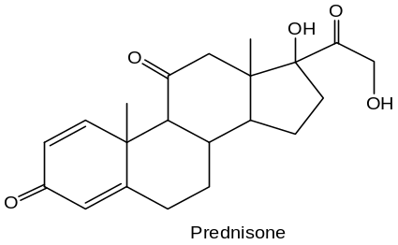
Prednisone

Which statement about Prednisone is correct?

A | It exhibits cis–trans isomerism.
B | It gives a reddish brown precipitate with Fehling’s solution.
C | It gives steamy white fumes upon reaction with PCl₅.
D | It reacts with cold, alkaline KMnO₄ to give a diol.

Section B

For each of the following questions, one or more of the three numbered statements 1 to 3 may be correct.

Decide whether each of the statements is or is not correct (you may find it helpful to put a tick against the statements which you consider to be correct).

The responses A to D should be selected on the basis of

A | B | C | D
1, 2 and 3 are correct | 1 and 2 are correct | 2 and 3 are correct | 1 only is correct

No other combination of statements is used as a correct response.

26. For the following pairs, in which one does the second compound have a smaller bond angle than the first?

1 | BF₄– and OF₂
2 | PH₄⁺ and NH₃
3 | AlCl₃ and BeCl₂

27. The rate equation of a reaction between X and Y is as follows:

rate = k[X]

Which of the following statements are true of the reaction?

1 | Doubling [X] will double the rate of reaction.
2 | X is involved in the rate-determining step of the reaction mechanism.
3 | A graph of [X] against time gives a straight line passing through the origin.

28. The following reaction between carbon monoxide and steam occurs in the presence of a suitable catalyst.

CO(g) + H₂O(l) CO₂(g) + H₂(g) ΔH = –40 kJ mol^{–1}

A higher equilibrium yield of hydrogen would be expected by using

1 | a lower temperature
2 | a higher pressure
3 | a more finely powdered catalyst.

The response A to D should be selected on the basis of

A | B | C | D
1, 2 and 3 are correct | 1 and 2 are correct | 2 and 3 are correct | 1 only is correct

No other combination of statements is used as a correct response.

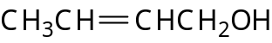
- Which of the following tests can be used to distinguish between the two organic compounds below?
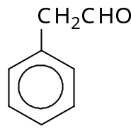
1 | Na metal
2 | Aqueous bromine, in the dark
3 | 2,4-Dinitrophenylhydrazine

30. A derivative of Rofecoxib, an efficient drug against arthritis, has the following structure.
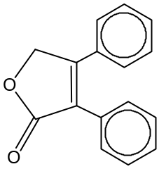
Rofecoxib

Which of the following statement about this compound are correct?

1 | It undergoes hydrogenation with hydrogen gas and nickel catalyst.
2 | It reacts with cold dilute alkaline KMnO₄ to give a diol.
3 | The compound is planar.

END OF PAPER

